**Kathmandu University**

**Department of Computer Science and Engineering**

**Dhulikhel, Kavre**



**Lab Report - I**

**[COMP 342]**

**Submitted by:**

Abhijeet Poudel (44)

**Submitted to:**

Mr. Dhiraj Shrestha

**Department of Computer Science and Engineering**

**Submission Date: 18/12/2022**

**TABLE OF CONTENTS**

Chapter 1: Introduction 4

1.1 Language Primitives and Graphics Library 4

Chapter 2: Helper Functions 4

2.1 toNVC() Function 4

2.2 toNVC2() Function 5

2.3 altList() Function 5

Chapter 3: Digital Differential Analyzer (DDA) Line Drawing Algorithm 5

3.1. Algorithm for DDA 5

3.2 Source Code 6

3.3 Output 9

Chapter 4: Bresenham’s Line Drawing Algorithm 10

4.1. Algorithm for Bresenham’s Line Drawing 10

4.2. Source Code 11

4.3. Output 14

4.3.1. For slope >1 (Joining points (-500,-500) & (250,250)) 14

4.3.1. For slope <1 (Joining points (-500, 500) & (250, -250)) 15

Chapter 5: Mid-point Line Drawing Algorithm 15

5.1. Algorithm for Mid- point Line Drawing: 15

5.2. Source Code 17

5.3. Output 20

5.3.1 For slope >1 (Joining points (-500,-500) & (250,250)) 20

5.3.2 For slope <1 (Joining points (-500,500) & (250,-250)) 21

Chapter 6: Conclusion 21

# Chapter 1: Introduction

## Language Primitives and Graphics Library

**Graphics Library:** PyOpenGL 3.1.6

**Programming Language:** Python 3.10.5

**Window Context:** GLFW

**Helpers:** Numpy

# Chapter 2: Helper Functions

Helper functions can help to make code more concise and easier to read by breaking up complex tasks into smaller tasks. This can also help to improve code maintainability and reduce the risk of errors by eliminating the need to repeat code. Additionally, helper functions can help to abstract away complex logic, making the code easier to understand and debug.

In this report we have made use of 3 different helper funtions namely 1 toNVC(), altList() anf toNVC2()

## toNVC() Function

def **toNVC**(*xList*, *yList*, *resolution*):

*for* i *in* range(**len**(*xList*)):

*xList*[i] = (*xList*[i]) / *(resolution)*

*yList*[i] = (*yList*[i]) / *(resolution)*

  coordinateList = **altList**(*xList*,*yList*)

*return* coordinateList

This code is used to convert a given list of coordinates from their original values to normalized values. It takes in two lists of x and y coordinates, as well as a resolution value. It then divides each coordinate by the resolution value, creating a normalized coordinate list. Finally, it returns the normalized coordinate list.

## toNVC2() Function

def **toNVC2**(*lst*,*resolution*):

*for* i *in* range(**len**(*lst*)):

*lst*[i] = (*lst*[i]) / *(resolution)*

*return* *lst*

This code takes a list of numbers (lst) and a resolution value and divides each item in the list by the resolution value. It returns the list with the new values. This code could be used for normalizing a list of data for a specific resolution.

## altList() Function

def **altList**(*lst1*, *lst2*):

*return* [sub[item] *for* item *in* range(**len**(*lst2*))

*for* sub *in* [*lst1*, *lst2*]]

This code is used to create an alternate list using two lists. The function altList takes in two lists, lst1 and lst2, and returns a list with the items of lst1 and lst2 alternating. For example, altList([1,2,3], [4,5,6]) would return [1,4,2,5,3,6].

# Chapter 3: Digital Differential Analyzer (DDA) Line Drawing Algorithm

## 3.1. Algorithm for DDA

**Step 1:** Consider initial point (x0, y0) and final point (x1, y1, ) as the starting and end points

**Step 2:** Calculate dx, dy and slope(m) of the given points as

dx= x1-x0

dy= y1-y0

m=dy/dx

**Step 3:** Calculate the number of steps required for the whole process as

If ( |dx| >|dy|) then steps= |dx|

Else steps= |dy|

**Step 4:** Calculate increment in x and y with the formula:

X_increament= dx/ steps

Y_ increament= du/steps

**Step5:** Calculate successive points start from x0 and y0 adding increament to the current value as

x=x+ X_increament

y=y+ Y_increament

**Step 6:** Repeat step 5 until x=x1

## 3.2 Source Code

*import* glfw

*import* numpy *as* np

*from* OpenGL.GL *import* *

*from* OpenGL.GL.shaders *import* compileProgram, compileShader

*from* helpers *import* **toNVC**

RESOLUTION = 800

def **window_resize**(*window*, *width*, *height*):

    glViewport(0, 0, *width*, *height*)

def **dda**(*start_x*,*start_y*,*end_x*,*end_y*, *resolution*):

  x_points = []

  y_points = []

  dx=*end_x*-*start_x*

  dy=*end_y*-*start_y*

  step=**abs**(dy)

*if* **abs**(dx)>**abs**(dy):

    step=**abs**(dx)

  new_x=*start_x*

  new_y=*start_y*

  x_inc=dx/step

  y_inc=dy/step

*for* i *in* range(step):

    x_points.**append**(new_x)

    y_points.**append**(new_y)

    new_x += x_inc

    new_y += y_inc

*return* **toNVC**(x_points,y_points,*resolution*)

def **main**():

    vertex_src = """

   #version 330

   layout(location=0) in vec2 aPos;

   void main(){

    gl_Position =vec4(aPos,0.0f,1.0f);

   }

  """

    fragment_src = """

  #version 330

  out vec4 FragColor;

  void main(){

    FragColor =vec4 (1.0f,1.0f,0.0f,1.0f);

  }

  """

*if* *not* glfw.init():

*raise* Exception("glfw cannot be initialised")

    window = glfw.create_window(RESOLUTION, RESOLUTION, "LAB2", None, None)

*if* *not* window:

        glfw.terminate()

*raise* Exception("glfw window cannot be created!")

*# glfw.set_window_pos(window,100,100)*

    glfw.set_window_size_callback(window, **window_resize**)

    glfw.make_context_current(window)

    temp = **dda**(-500, -500, 250, 250, RESOLUTION)

    vertices = np.**array**(temp, *dtype*=np.float32)

    render_count = **round**(**len**(temp))

**print**(temp)

    indices = np.**array**([i *for* i *in* range(1, render_count + 1)], *dtype*=np.uint32)

    shader = compileProgram(

        compileShader(vertex_src, GL_VERTEX_SHADER),

        compileShader(fragment_src, GL_FRAGMENT_SHADER),

    )

    vertex_buffer_object = glGenBuffers(1)

    glBindBuffer(GL_ARRAY_BUFFER, vertex_buffer_object)

    glBufferData(GL_ARRAY_BUFFER, vertices.nbytes, vertices, GL_STATIC_DRAW)

    element_buffer_object = glGenBuffers(1)

    glBindBuffer(GL_ELEMENT_ARRAY_BUFFER, element_buffer_object)

    glBufferData(GL_ELEMENT_ARRAY_BUFFER, indices.nbytes, indices, GL_STATIC_DRAW)

    glEnableVertexAttribArray(0)

    glVertexAttribPointer(0, 2, GL_FLOAT, GL_FALSE, 00, ctypes.c_void_p(0))

    glUseProgram(shader)

**print**(render_count)

*while* *not* glfw.window_should_close(window):

        glfw.poll_events()

        glDrawElements(GL_POINTS, **len**(indices), GL_UNSIGNED_BYTE, None)

        glfw.swap_buffers(window)

    glfw.terminate()

**main**()

## 3.3 Output

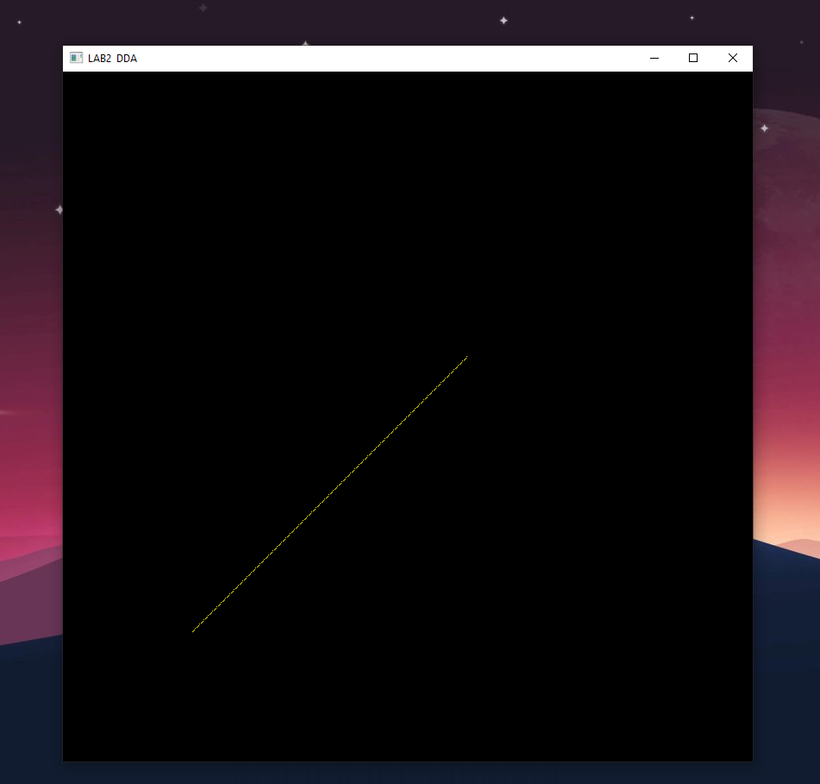

# Chapter 4: Bresenham’s Line Drawing Algorithm

## 4.1. Algorithm for Bresenham’s Line Drawing

**Step 1:** Consider initial point (x0, y0) and final point (x1, y1, ) as the starting and end points

**Step 2:** Calculate dx and dy of the given points as

dx= x1-x0

dy= y1-y0

**Step 3:** Calculate initial decision Parameter as pk= 2* dy – dx

**Step 4:** At each xk along the line, starting from k=0, perform the following test:

If pk < 0 then pk=pk+ 2 * dy

Else Check the slope of the line

If m>0 (i.e., positive slope) y0=y0+1

If m<0 (i.e., negative slope) y0=y0-1

And, pk = pk + 2 * dy – 2 * dx

**Step 5:** Change the value of x as

If x0 < x1 then x0=x0+1

Else x0 = x0 -1

**Step 6:** Repeat step 4 and 5 for dx number of times

## 4.2. Source Code

*import* glfw

*import* numpy *as* np

*from* OpenGL.GL *import* *

*from* OpenGL.GL.shaders *import* compileProgram, compileShader

*from* helpers *import* **toNVC**

RESOLUTION = 800

def **window_resize**(*window*, *width*, *height*):

    glViewport(0, 0, *width*, *height*)

def **bh**(*x_start*, *y_start*, *x_end*, *y_end*, *res*):

    dx = **abs**(*x_end* - *x_start*)

    dy = **abs**(*y_end* - *y_start*)

    pk = 2 * dy - dx

    x_coordinates = np.**array**([])

    y_coordinates = np.**array**([])

*for* i *in* range(0, dx + 1):

        x_coordinates = np.**append**(x_coordinates, *x_start*)

        y_coordinates = np.**append**(y_coordinates, *y_start*)

*if* *x_start* < *x_end*:

*x_start* = *x_start* + 1

*else*:

*x_start* = *x_start* - 1

*if* pk < 0:

            pk = pk + 2 * dy

*else*:

*if* *y_start* < *y_end*:

*y_start* = *y_start* + 1

*else*:

*y_start* = *y_start* - 1

            pk = pk + 2 * dy - 2 * dx

*return* **toNVC**(x_coordinates, y_coordinates, *res*)

def **main**():

    vertex_src = """

   #version 330

   layout(location=0) in vec2 aPos;

   void main(){

    gl_Position =vec4(aPos,0.0f,1.0f);

   }

  """

    fragment_src = """

  #version 330

  out vec4 FragColor;

  void main(){

    FragColor =vec4 (1.0f,1.0f,0.0f,1.0f);

  }

  """

*if* *not* glfw.init():

*raise* Exception("glfw cannot be initialised")

    window = glfw.create_window(RESOLUTION, RESOLUTION, "LAB2 Bresenham", None, None)

*if* *not* window:

        glfw.terminate()

*raise* Exception("glfw window cannot be created!")

*# glfw.set_window_pos(window,100,100)*

    glfw.set_window_size_callback(window, **window_resize**)

    glfw.make_context_current(window)

    temp = **bh**(-500, -500, 250, 250, RESOLUTION)

    vertices = np.**array**(temp, *dtype*=np.float32)

    render_count = **round**(**len**(temp))

**print**(temp)

    indices = np.**array**([i *for* i *in* range(1, render_count + 1)], *dtype*=np.uint32)

    shader = compileProgram(

        compileShader(vertex_src, GL_VERTEX_SHADER),

        compileShader(fragment_src, GL_FRAGMENT_SHADER),

    )

    vertex_buffer_object = glGenBuffers(1)

    glBindBuffer(GL_ARRAY_BUFFER, vertex_buffer_object)

    glBufferData(GL_ARRAY_BUFFER, vertices.nbytes, vertices, GL_STATIC_DRAW)

    element_buffer_object = glGenBuffers(1)

    glBindBuffer(GL_ELEMENT_ARRAY_BUFFER, element_buffer_object)

    glBufferData(GL_ELEMENT_ARRAY_BUFFER, indices.nbytes, indices, GL_STATIC_DRAW)

    glEnableVertexAttribArray(0)

    glVertexAttribPointer(0, 2, GL_FLOAT, GL_FALSE, 0, ctypes.c_void_p(0))

    glUseProgram(shader)

*while* *not* glfw.window_should_close(window):

        glfw.poll_events()

        glDrawElements(GL_POINTS, **len**(indices), GL_UNSIGNED_BYTE, None)

        glfw.swap_buffers(window)

    glfw.terminate()

**main**()

## 4.3. Output

### 4.3.1. For slope >1 (Joining points (-500, -500) & (250,250))

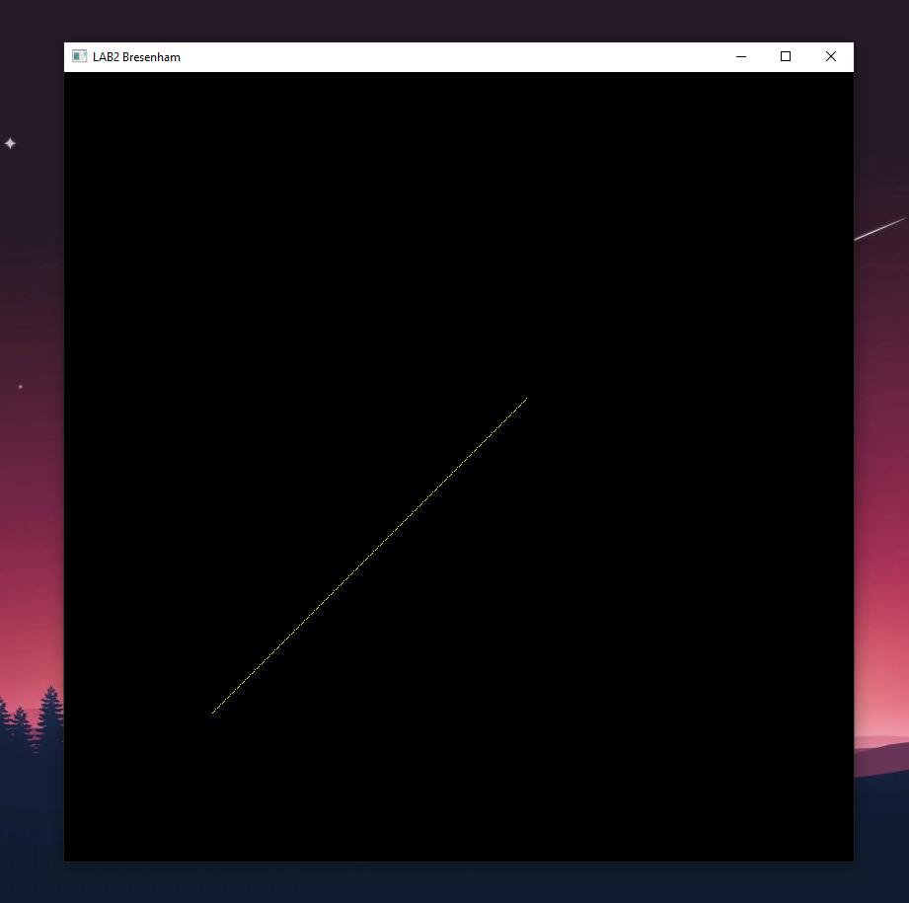

### 4.3.1. For slope <1 (Joining points (-500, 500) & (250, -250))

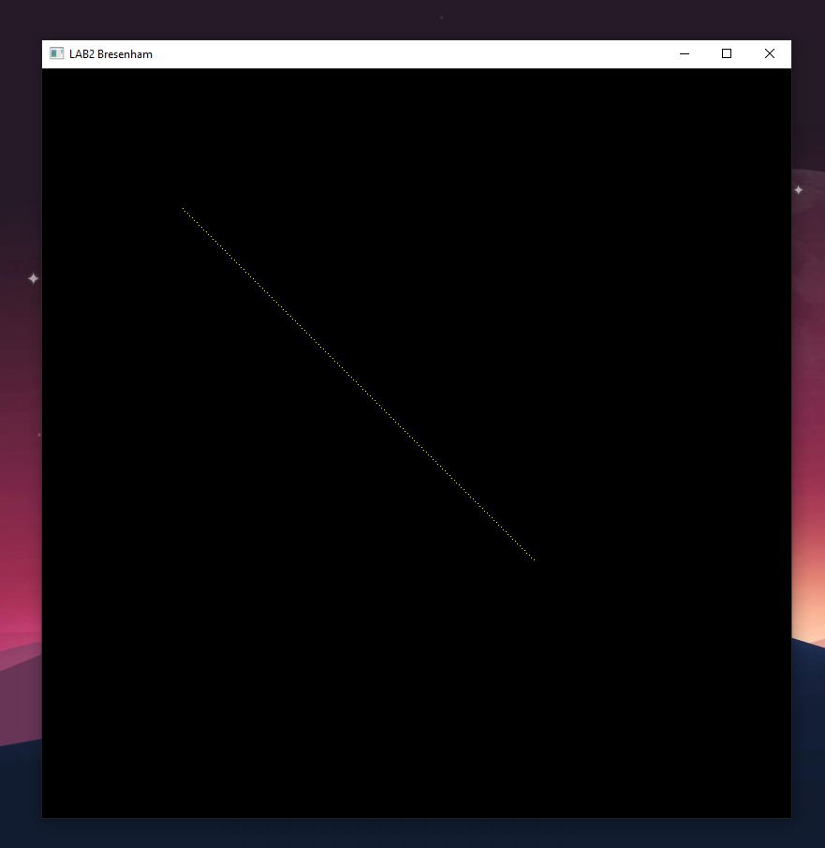

# Chapter 5: Mid-point Line Drawing Algorithm

## 5.1. Algorithm for Mid- point Line Drawing:

**Step 1:** Consider initial point (x0, y0) and final point (x1, y1, ) as the starting and end points

**Step 2:** Calculate dx and dy of the given points as

dx= x1-x0

dy= y1-y0

**Step 3:** Check if slope of the line is positive or negative by:

If dx> dy and dy != 0

Decide=0

Initial decision parameter ( pk) = dx – ( dy / 2)

Else

Decide= 1

Initial decision parameter ( pk) = dy – ( dx / 2)

**Step 4:** At each point along the line the value of decide is checked as

1. If decide =1
2. x = x + 1
3. if pk < 0

pk= pk + dy

1. else

pk = pk + (dy – dx)

y = y + 1

1. Else
2. Y = y – 1
3. If pk < 0

Pk = pk + dx

1. Else

Pk = pk + ( dx – dy)

X = x+1

**Step 5:** Repeat Step 4 until the following condition is fulfilled

1. If decide =1 then

Condition: x< x1

1. Else

Condition: y > y1

## 5.2. Source Code

*import* glfw

*import* numpy *as* np

*from* OpenGL.GL *import* *

*from* OpenGL.GL.shaders *import* compileProgram, compileShader

*from* helpers *import* **toNVC**

RESOLUTION = 800

def **window_resize**(*window*, *width*, *height*):

    glViewport(0, 0, *width*, *height*)

def **mp**(*x0*, *y0*, *x1*, *y1*, *res*):

  dx = *x1* - *x0*

  dy = *y1* - *y0*

  x = *x0*

  y = *y0*

*if* dx > dy *and* dy != 0:

   decide = 0

   pk = dx - (dy / 2)

*else*:

    decide = 1

    pk = dy - (dx / 2)

  x_coordinates = np.**array**([])

  y_coordinates = np.**array**([])

**print**(y > *y1*)

*while* (x < *x1*) *if* (decide) *else* (y > *y1*):

**print**("hi")

    x_coordinates = np.**append**(x_coordinates, x)

    y_coordinates = np.**append**(y_coordinates, y)

*if* decide:

      x = x + 1

**print**("hi")

*if* pk < 0:

       pk = pk + dy

*else*:

        pk = pk + (dy - dx)

        y = y + 1

*else*:

      y = y - 1

*if* pk < 0:

       pk = pk + dx

*else*:

        pk = pk + (dx - dy)

        x = x + 1

*return* **toNVC**(x_coordinates, y_coordinates, *res*)

def **main**():

    vertex_src = """

   #version 330

   layout(location=0) in vec2 aPos;

   void main(){

    gl_Position =vec4(aPos,0.0f,1.0f);

   }

  """

    fragment_src = """

  #version 330

  out vec4 FragColor;

  void main(){

    FragColor =vec4 (1.0f,1.0f,0.0f,1.0f);

  }

  """

*if* *not* glfw.init():

*raise* Exception("glfw cannot be initialised")

    window = glfw.create_window(RESOLUTION, RESOLUTION, "LAB2 MP", None, None)

*if* *not* window:

        glfw.terminate()

*raise* Exception("glfw window cannot be created!")

*# glfw.set_window_pos(window,100,100)*

    glfw.set_window_size_callback(window, **window_resize**)

    glfw.make_context_current(window)

    temp = **mp**(-500, -500, 250, 250, RESOLUTION)

    vertices = np.**array**(temp, *dtype*=np.float32)

    render_count = **round**(**len**(temp))

**print**(temp)

    indices = np.**array**([i *for* i *in* range(1, render_count + 1)], *dtype*=np.uint32)

    shader = compileProgram(

        compileShader(vertex_src, GL_VERTEX_SHADER),

        compileShader(fragment_src, GL_FRAGMENT_SHADER),

    )

    vertex_buffer_object = glGenBuffers(1)

    glBindBuffer(GL_ARRAY_BUFFER, vertex_buffer_object)

    glBufferData(GL_ARRAY_BUFFER, vertices.nbytes, vertices, GL_STATIC_DRAW)

    element_buffer_object = glGenBuffers(1)

    glBindBuffer(GL_ELEMENT_ARRAY_BUFFER, element_buffer_object)

    glBufferData(GL_ELEMENT_ARRAY_BUFFER, indices.nbytes, indices, GL_STATIC_DRAW)

    glEnableVertexAttribArray(0)

    glVertexAttribPointer(0, 2, GL_FLOAT, GL_FALSE, 0, ctypes.c_void_p(0))

    glUseProgram(shader)

*while* *not* glfw.window_should_close(window):

        glfw.poll_events()

        glDrawElements(GL_POINTS, **len**(indices), GL_UNSIGNED_BYTE, None)

        glfw.swap_buffers(window)

    glfw.terminate()

**main**()

## 5.3. Output

### 5.3.1 For slope >1 ( Joining points (-500,-500) & (250,250) )

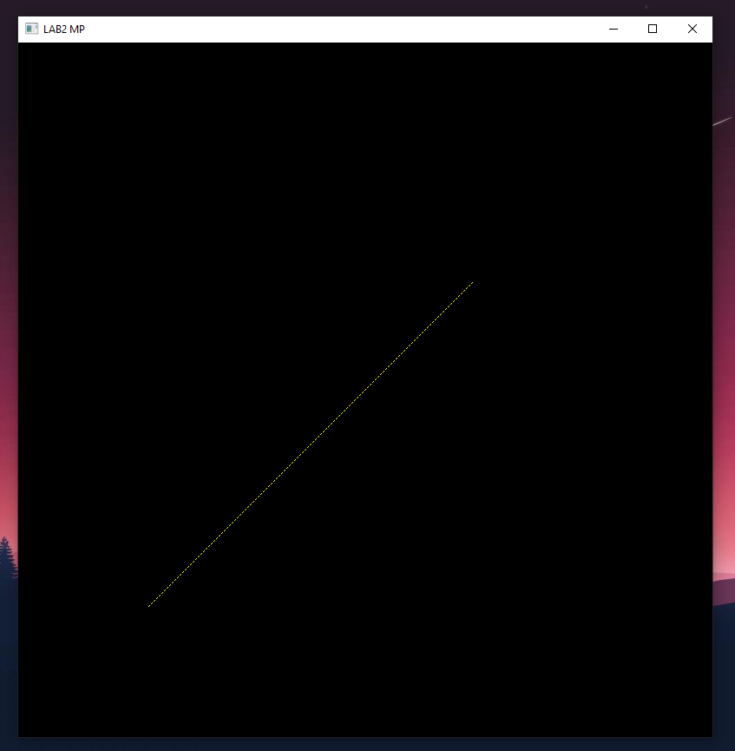

### 5.3.2 For slope <1 ( Joining points (-500,500) & (250,-250) )

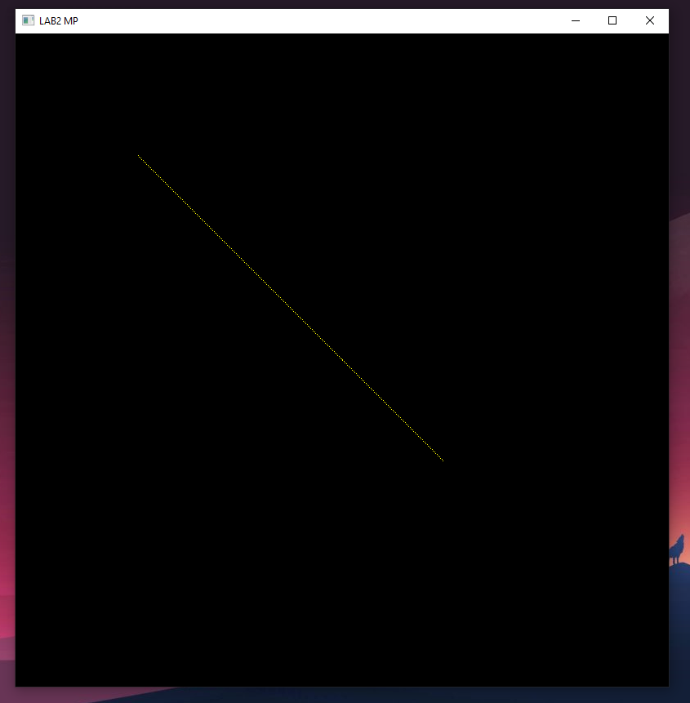

# Chapter 6: Conclusion

Through the completion of this lab work, we were able to gain a better understanding of how the three-line drawing algorithms (DDA, Bresenham and Mid-Point) work and how to implement them into GLFW and OpenGL in order to draw lines on the screen. To do that, we had to convert the co-ordinates obtained from the algorithms into normalized viewing coordinates (NVC) and then use those coordinates to draw the lines. Normalizing the coordinates was necessary as any coordinate exceeding either -1 or 1 in any direction is automatically clipped by OpenGL. Therefore, normalizing the coordinates helped us to draw lines without any problem.. In the end, we successfully implemented the three algorithms and were able to draw lines on the screen.